**OUTPUT**

JUnit Testing Exercises

1. Exercise 1

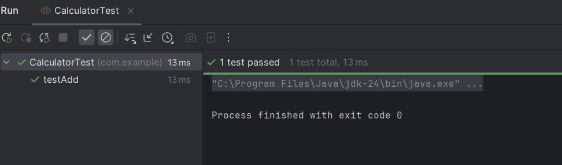

1. Exercise 3

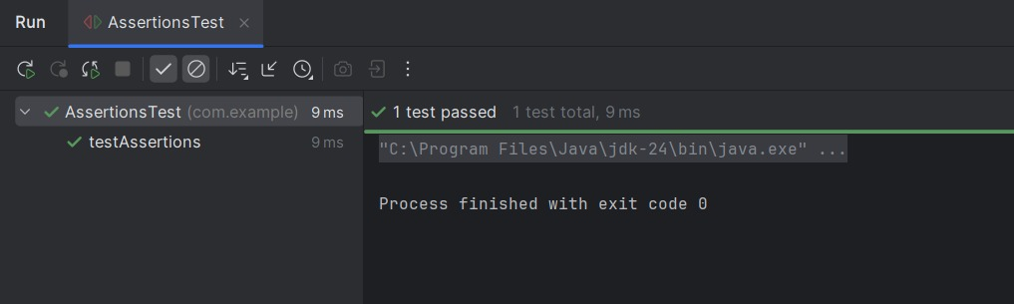

1. Exercise 4

